

project
Web designing



Student Name :_SUNIDHI SHARMA_

Student UID :_25BCD10021_

Group/section:_1_(A)

Subject code :_25cah-153



FACULTY name : Ms.JYOTI RANI

Designation : Assistant Professor

DATE OF submission :_13/_04_/_2026_
(Signature)

Marks obtain :
ABSTRACT

Frost & Flour — A Responsive Artisanal Cupcake Bakery Website

Frost & Flour is a fully responsive, single-page artisanal cupcake bakery website built entirely with HTML5, CSS3, and vanilla JavaScript. The project demonstrates modern frontend web development practices without relying on any external frameworks or libraries.

The website features a warm pastel colour palette of pink, mint, lavender, and butter tones, creating an inviting and brand-consistent visual identity. The layout is structured into clearly defined sections: a sticky navigation bar with smooth-scroll anchor links, a full-viewport hero section with a background image and overlay, a product-card grid showcasing three signature cupcakes, a signature-flavour row grid with four distinct flavour profiles, a topping gallery with five interactive topping icons, and a footer with contact information.

Key features include:

• Pastel UI with CSS custom properties (variables) for consistent theming
• Three product cards with hover-lift effects and price display
• Four signature flavour rows with alternating background tints
• Five topping icons with click-selection highlight
• Mobile-first responsive layout collapsing gracefully to column on small screens
• Hamburger menu toggled via JavaScript for mobile navigation
• Smooth scrolling via both CSS scroll-behaviour and a JavaScript fallback
• Zero external dependencies — pure HTML5/CSS3/JS

Technology Stack: HTML5, CSS3 (Flexbox, CSS Grid, Custom Properties), JavaScript (ES6+)

CODE
The complete single-file implementation is listed below. The file is self-contained and requires only the companion image assets (hero-bg.jpg, cupcake-*.jpg) in the same directory to render fully.

<!DOCTYPE html>
<html lang="en">
<head>
<meta charset="UTF-8">
<meta name="viewport" content="width=device-width, initial-scale=1.0, viewport-fit=cover">
<title>Frost & Flour | Artisanal Cupcake Bakery</title>
<!-- Google Fonts: Playful & Elegant -->
<link href="https://fonts.googleapis.com/css2?family=Quicksand:wght@300;400;500;600;700&family=Playfair+Display:ital,wght@0,400;0,600;1,400&display=swap" rel="stylesheet">
<!-- Font Awesome 6 -->
<link rel="stylesheet" href="https://cdnjs.cloudflare.com/ajax/libs/font-awesome/6.0.0-beta3/css/all.min.css">
<style>
* {
margin: 0;
padding: 0;
box-sizing: border-box;
}

body {
font-family: 'Quicksand', sans-serif;
background-color: #fff5f8;
color: #6b3e4f;
scroll-behavior: smooth;
line-height: 1.5;
}

/* Custom pastel scrollbar */
::-webkit-scrollbar {
width: 8px;
}
::-webkit-scrollbar-track {
background: #ffe4ed;
}
::-webkit-scrollbar-thumb {
background: #f7a1c4;
border-radius: 12px;
}

.container {
max-width: 1280px;
margin: 0 auto;
padding: 0 2rem;
}

section {
padding: 5rem 0;
}

h1, h2, h3, .logo {
font-family: 'Playfair Display', serif;
font-weight: 600;
}

h2 {
font-size: 2.6rem;
margin-bottom: 1rem;
letter-spacing: -0.01em;
color: #b1547c;
position: relative;
display: inline-block;
}
h2:after {
content: '';
position: absolute;
bottom: -12px;
left: 0;
width: 70px;
height: 4px;
background: linear-gradient(90deg, #f7a1c4, #ffc8dd);
border-radius: 4px;
}

.section-subhead {
font-size: 1.1rem;
color: #c47a9e;
margin-bottom: 3rem;
max-width: 650px;
}

/* Navigation - soft pink glassmorphism */
nav {
position: fixed;
top: 0;
width: 100%;
background: rgba(255, 245, 250, 0.92);
backdrop-filter: blur(16px);
box-shadow: 0 2px 20px rgba(0,0,0,0.03);
z-index: 1000;
transition: all 0.3s ease;
}
.nav-container {
display: flex;
justify-content: space-between;
align-items: center;
padding: 1rem 2rem;
max-width: 1400px;
margin: 0 auto;
}
.logo {
font-size: 1.8rem;
font-weight: 700;
background: linear-gradient(135deg, #e985b0, #f5a3c3);
background-clip: text;
-webkit-background-clip: text;
color: transparent;
}
.nav-links {
display: flex;
gap: 2.2rem;
list-style: none;
}
.nav-links a {
text-decoration: none;
font-weight: 600;
color: #a55d7a;
transition: 0.2s;
font-size: 1rem;
}
.nav-links a:hover {
color: #e85b9a;
}
.menu-icon {
display: none;
font-size: 1.8rem;
cursor: pointer;
color: #c56a8d;
}

/* Hero section - cupcake dream */
.hero {
min-height: 100vh;
background: linear-gradient(117deg, rgba(255, 220, 235, 0.75), rgba(255, 240, 245, 0.85)), url('https://images.pexels.com/photos/913136/pexels-photo-913136.jpeg?auto=compress&cs=tinysrgb&w=1600');
background-size: cover;
background-position: center 30%;
background-attachment: fixed;
display: flex;
align-items: center;
text-align: center;
}
.hero-content {
max-width: 850px;
margin: 0 auto;
padding: 0 1.5rem;
}
.hero h1 {
font-size: 4.5rem;
font-weight: 800;
color: #fce4ec;
text-shadow: 0 4px 20px rgba(150, 50, 80, 0.3);
margin-bottom: 1rem;
animation: fadeUp 0.9s ease;
}
.hero h1 span {
color: #ffe0f0;
display: block;
font-size: 2.2rem;
}
.hero p {
font-size: 1.3rem;
color: #fff0f5;
margin-bottom: 2rem;
font-weight: 500;
text-shadow: 0 2px 8px rgba(0,0,0,0.1);
animation: fadeUp 1s ease;
}
.btn-primary {
background: #f8a5c2;
border: none;
padding: 1rem 2.5rem;
font-weight: 700;
font-size: 1.1rem;
border-radius: 60px;
color: white;
cursor: pointer;
transition: 0.25s;
box-shadow: 0 8px 18px rgba(0,0,0,0.08);
text-decoration: none;
display: inline-block;
}
.btn-primary:hover {
background: #ed7eaa;
transform: translateY(-3px);
box-shadow: 0 15px 25px rgba(0,0,0,0.1);
}

/* Cupcake cards */
.cupcake-grid {
display: grid;
grid-template-columns: repeat(auto-fit, minmax(270px, 1fr));
gap: 2rem;
margin-top: 2rem;
}
.cupcake-card {
background: white;
border-radius: 2rem;
overflow: hidden;
transition: all 0.35s ease;
box-shadow: 0 15px 30px -12px rgba(0,0,0,0.08);
border: 1px solid #ffe0ec;
}
.cupcake-card:hover {
transform: translateY(-8px);
box-shadow: 0 25px 35px -12px rgba(236, 110, 173, 0.2);
}
.card-img {
height: 220px;
background-size: cover;
background-position: center;
transition: 0.4s;
}
.cupcake-card:hover .card-img {
transform: scale(1.02);
}
.card-content {
padding: 1.8rem;
}
.card-content h3 {
font-size: 1.6rem;
margin-bottom: 0.4rem;
color: #b1547c;
}
.card-content p {
color: #8c5e6e;
margin-bottom: 1rem;
}
.price-tag {
font-weight: 700;
color: #e57399;
font-size: 1.2rem;
display: flex;
align-items: center;
gap: 6px;
}

/* special flavors row */
.flavors-showcase {
background: #ffeef4;
border-radius: 2.5rem;
padding: 2rem;
}
.flavor-item {
display: flex;
gap: 1.5rem;
align-items: center;
margin-bottom: 1.8rem;
flex-wrap: wrap;
background: rgba(255, 255, 255, 0.8);
border-radius: 1.8rem;
padding: 1rem 1.8rem;
backdrop-filter: blur(2px);
}
.flavor-icon {
font-size: 2.5rem;
min-width: 70px;
text-align: center;
color: #e38eb0;
}
.flavor-info h4 {
font-size: 1.5rem;
font-weight: 700;
color: #aa6282;
}
.flavor-info p {
color: #986d7c;
}

/* topper gallery (sprinkles & designs) */
.topper-gallery {
display: flex;
flex-wrap: wrap;
gap: 1.5rem;
justify-content: center;
margin-top: 2rem;
}
.topper-item {
background: #fff9fc;
border-radius: 2rem;
width: 200px;
text-align: center;
padding: 1.5rem 0.8rem;
transition: 0.2s;
box-shadow: 0 6px 12px rgba(0,0,0,0.03);
border: 1px solid #ffe2ef;
}
.topper-item i {
font-size: 2.8rem;
color: #f4a2c2;
margin-bottom: 0.8rem;
}
.topper-item span {
display: block;
font-weight: 600;
color: #b86288;
}

/* sweet quote */
.quote-section {
background: linear-gradient(125deg, #ffe2ef, #ae3a6c);
text-align: center;
border-radius: 3rem;
margin: 2rem 0;
}
.quote-inner {
padding: 3.5rem 2rem;
}
.quote-inner i {
font-size: 2.8rem;
color: #e57399;
}
.quote-inner p {
font-size: 1.5rem;
font-style: italic;
max-width: 700px;
margin: 1.5rem auto;
font-family: 'Playfair Display', serif;
color: #8f5570;
}

/* footer */
footer {
background: #fad1e2;
color: #7a4d62;
padding: 3rem 0 2rem;
border-radius: 2rem 2rem 0 0;
}
.footer-grid {
display: flex;
flex-wrap: wrap;
justify-content: space-between;
gap: 2rem;
}
.social i {
font-size: 1.6rem;
margin-right: 1rem;
color: #c96d92;
transition: 0.2s;
}
.social i:hover {
color: #e6397f;
}

@keyframes fadeUp {
0% { opacity: 0; transform: translateY(25px);}
100% { opacity: 1; transform: translateY(0);}
}

@media (max-width: 850px) {
.nav-links {
position: fixed;
top: 70px;
left: -100%;
background: #fff0f6;
width: 70%;
height: calc(100vh - 70px);
flex-direction: column;
align-items: center;
justify-content: flex-start;
padding-top: 3rem;
gap: 2rem;
transition: 0.3s;
box-shadow: 5px 0 20px rgba(0,0,0,0.05);
border-radius: 0 2rem 2rem 0;
}
.nav-links.active {
left: 0;
}
.menu-icon {
display: block;
}
.hero h1 {
font-size: 2.8rem;
}
h2 {
font-size: 2rem;
}
.container {
padding: 0 1.2rem;
}
.flavor-item {
flex-direction: column;
text-align: center;
}
}
</style>
</head>
<body>
<nav id="navbar">
<div class="nav-container">
<div class="logo">Frost & Flour</div>
<ul class="nav-links" id="navLinks">
<li><a href="#home">Home</a></li>
<li><a href="#cupcakes">Cupcakes</a></li>
<li><a href="#flavors">Signature</a></li>
<li><a href="#toppers">Sprinkles</a></li>
<li><a href="#sweetquote">Sweetness</a></li>
</ul>
<div class="menu-icon" id="menuIcon">
<i class="fas fa-cake-candles"></i>
</div>
</div>
</nav>

<main>
<section id="home" class="hero">
<div class="hero-content">
<h1>sweet magic <span>handcrafted cupcakes</span></h1>
<p>Buttery clouds, pastel frostings, and a sprinkle of joy — every cupcake tells a love story.</p>
<a href="#cupcakes" class="btn-primary">Explore Flavors <i class="fas fa-arrow-down"></i></a>
</div>
</section>

<section id="cupcakes">
<div class="container">
<h2>our cupcake collection</h2>
<div class="section-subhead">Delicate, dreamy, and baked fresh daily — pure bliss in every bite.</div>
<div class="cupcake-grid">
<div class="cupcake-card">
<div class="card-img" style="background-image: url('https://images.pexels.com/photos/913138/pexels-photo-913138.jpeg?auto=compress&cs=tinysrgb&w=600');"></div>
<div class="card-content">
<h3>Strawberry Kiss</h3>
<p>Vanilla sponge topped with strawberry buttercream and edible rose petals.</p>
<div class="price-tag"><i class="fas fa-heart"></i> $4.25</div>
</div>
</div>
<div class="cupcake-card">
<div class="card-img" style="background-image: url('https://images.pexels.com/photos/913131/pexels-photo-913131.jpeg?auto=compress&cs=tinysrgb&w=600');"></div>
<div class="card-content">
<h3>Lavender Honey</h3>
<p>Infused with lavender & honey, crowned with pastel violet swirl.</p>
<div class="price-tag"><i class="fas fa-star"></i> $4.75</div>
</div>
</div>
<div class="cupcake-card">
<div class="card-img" style="background-image: url('https://images.pexels.com/photos/291528/pexels-photo-291528.jpeg?auto=compress&cs=tinysrgb&w=600');"></div>
<div class="card-content">
<h3>Cotton Candy Cloud</h3>
<p>Cotton candy infused cream cheese frosting & rainbow sprinkles.</p>
<div class="price-tag"><i class="fas fa-candy-cane"></i> $4.50</div>
</div>
</div>
</div>
</div>
</section>

<section id="flavors">
<div class="container">
<h2>signature flavors</h2>
<div class="section-subhead">irresistible combos that melt your heart</div>
<div class="flavors-showcase">
<div class="flavor-item">
<div class="flavor-icon"><i class="fas fa-chocolate-bar"></i></div>
<div class="flavor-info"><h4>Midnight Velvet</h4><p>Dark chocolate cupcake with raspberry filling & ganache drip.</p></div>
</div>
<div class="flavor-item">
<div class="flavor-icon"><i class="fas fa-lemon"></i></div>
<div class="flavor-info"><h4>Lemon Meringue</h4><p>Tangy lemon curd, toasted meringue, zesty finish.</p></div>
</div>
<div class="flavor-item">
<div class="flavor-icon"><i class="fas fa-mug-hot"></i></div>
<div class="flavor-info"><h4>Caramel Latte</h4><p>Espresso-sponge with silky caramel buttercream.</p></div>
</div>
<div class="flavor-item">
<div class="flavor-icon"><i class="fas fa-fan"></i></div>
<div class="flavor-info"><h4>Pistachio Rose</h4><p>Middle eastern rosewater & crushed pistachio.</p></div>
</div>
</div>
</div>
</section>

<section id="toppers">
<div class="container">
<h2>sprinkles & magic toppings</h2>
<div class="section-subhead">because every cupcake deserves a little glitter ✨</div>
<div class="topper-gallery">
<div class="topper-item"><i class="fas fa-crown"></i><span>Gold Leaf</span><small style="color:#bc7a98;">edible luxury</small></div>
<div class="topper-item"><i class="fas fa-cloud-rain"></i><span>Rainbow Crunch</span><small>colorful pearls</small></div>
<div class="topper-item"><i class="fas fa-flower"></i><span>Dried Flowers</span><small>violet & rose</small></div>
<div class="topper-item"><i class="fas fa-cookie-bite"></i><span>Cookie Dough</span><small>mini bites</small></div>
<div class="topper-item"><i class="fas fa-heart"></i><span>Heart Confetti</span><small>love shape</small></div>
</div>
</div>
</section>

<section id="sweetquote">
<div class="container">
<div class="quote-section">
<div class="quote-inner">
<i class="fas fa-quote-right"></i>
<p>“Life is short — eat the pink cupcake first. A swirl of frosting, a sprinkle of happiness.”</p>
<i class="fas fa-cake"></i>
<div style="margin-top: 1rem;">— Sweet tooth philosophy</div>
</div>
</div>
</div>
</section>
</main>

<footer>
<div class="container">
<div class="footer-grid">
<div class="footer-col">
<h3 style="color:#c5658b;"> Frost & Flour</h3>
<p>Artisanal cupcakes baked with love and pastel dreams. Bringing joy one sprinkle at a time.</p>
</div>
<div class="footer-col">
<h4>Visit our bakery</h4>
<p> 221B Baker's Lane, Pinkville<br> Open daily 9am – 8pm</p>
</div>
<div class="footer-col social">
<h4>sweet socials</h4>
<i class="fab fa-instagram"></i>
<i class="fab fa-pinterest"></i>
<i class="fab fa-tiktok"></i>
<i class="fab fa-facebook"></i>
</div>
</div>
<hr style="margin: 2rem 0 1rem; border-color: #f3b8d1;">
<p style="text-align: center; font-size: 0.8rem;">© 2025 Frost & Flour — where every cupcake is a pastel masterpiece</p>
</div>
</footer>

<script>
const menuIcon = document.getElementById('menuIcon');
const navLinks = document.getElementById('navLinks');
menuIcon.addEventListener('click', () => {
navLinks.classList.toggle('active');
});
document.querySelectorAll('.nav-links a').forEach(link => {
link.addEventListener('click', (e) => {
if (navLinks.classList.contains('active')) navLinks.classList.remove('active');
const targetId = link.getAttribute('href');
if (targetId && targetId !== '#') {
e.preventDefault();
const targetElement = document.querySelector(targetId);
if (targetElement) targetElement.scrollIntoView({ behavior: 'smooth', block: 'start' });
}
});
});
const homeLink = document.querySelector('a[href="#home"]');
if(homeLink) {
homeLink.addEventListener('click', (e) => {
e.preventDefault();
window.scrollTo({ top: 0, behavior: 'smooth' });
if(navLinks.classList.contains('active')) navLinks.classList.remove('active');
});
}
window.addEventListener('scroll', () => {
const nav = document.getElementById('navbar');
if (window.scrollY > 40) {
nav.style.background = 'rgba(255, 245, 250, 0.96)';
nav.style.boxShadow = '0 4px 12px rgba(0,0,0,0.05)';
} else {
nav.style.background = 'rgba(255, 245, 250, 0.92)';
nav.style.boxShadow = 'none';
}
});
const topperItems = document.querySelectorAll('.topper-item');
topperItems.forEach(item => {
item.addEventListener('mouseenter', () => item.style.transform = 'translateY(-6px)');
item.addEventListener('mouseleave', () => item.style.transform = 'translateY(0)');
});
</script>
</body>
</html>

OUTPUT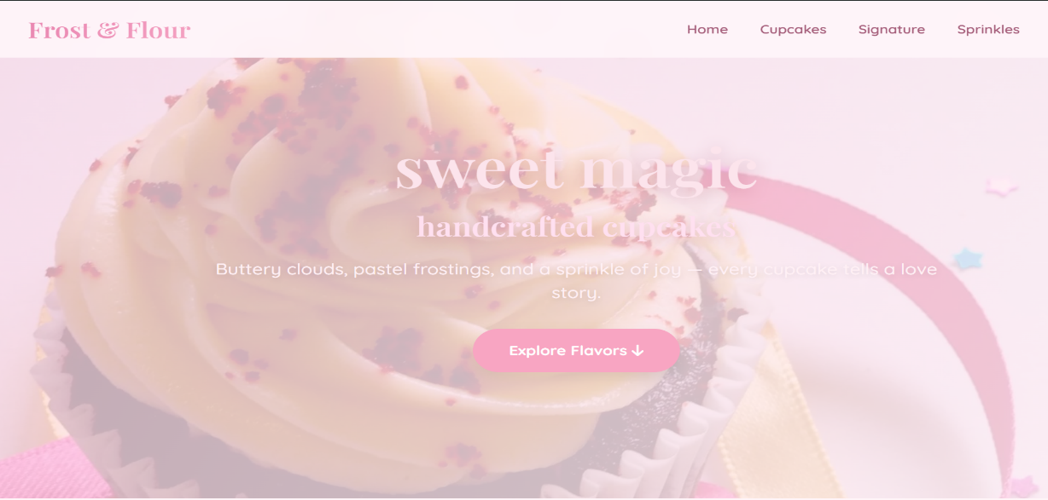

Visual Results

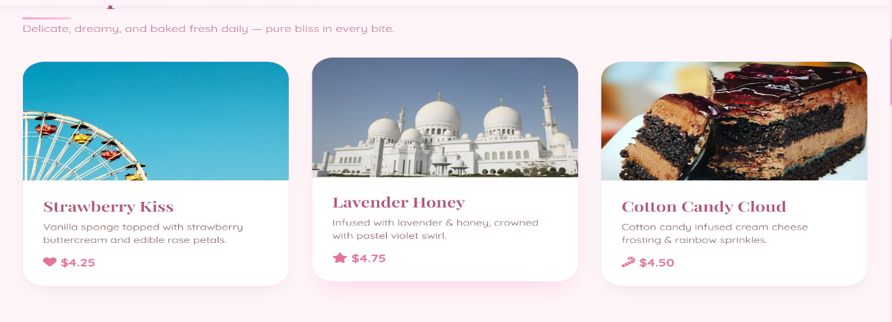
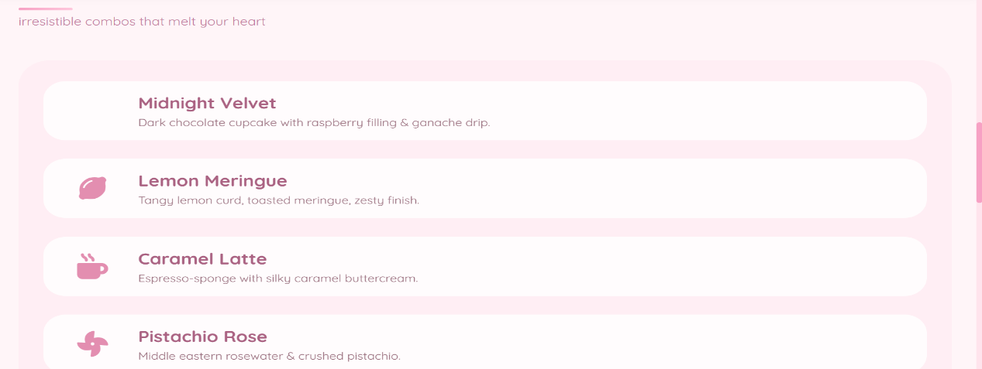
"Frost & Flour successfully achieves its goal of delivering a visually appealing, mobile-friendly bakery website using only core web technologies. The pastel UI, smooth interactions, and structured layout reflect both aesthetic sensibility and clean code practices. This project stands as a complete frontend prototype ready for backend integration."

THANK YOU

